1. Design a standard calculator using Swing components that supports basic operations

(Addition, Subtraction, Multiplication, and Division). Implement this with Intellij IDEA

Implementation Guidelines:

○ Use JTextField to display input/output.

○ Use JButton for digits (0-9) and operations ( +, -, *, /, =, %, square, square-root,

cube, C, etc. ).

○ Implement event handling for button clicks.

○ Display results in the text field.

import javax.swing.*;

import java.awt.*;

import java.awt.event.*;

public class Calculator extends JFrame implements ActionListener {

JTextField display;

JButton[] numButtons = new JButton[10];

JButton addBtn, subBtn, mulBtn, divBtn, eqBtn, clrBtn;

JButton modBtn, sqrtBtn, squareBtn, cubeBtn;

String operator = "";

double num1 = 0, num2 = 0;

public Calculator() {

setTitle("Standard Calculator");

setSize(400, 500);

setLayout(null);

setDefaultCloseOperation(EXIT_ON_CLOSE);

display = new JTextField();

display.setBounds(30, 30, 320, 40);

display.setEditable(false);

add(display);

addBtn = new JButton("+");

subBtn = new JButton("-");

mulBtn = new JButton("*");

divBtn = new JButton("/");

eqBtn = new JButton("=");

clrBtn = new JButton("C");

modBtn = new JButton("%");

sqrtBtn = new JButton("√");

squareBtn = new JButton("x²");

cubeBtn = new JButton("x³");

JButton[] opButtons = {addBtn, subBtn, mulBtn, divBtn, eqBtn, clrBtn, modBtn, sqrtBtn, squareBtn, cubeBtn};

for (int i = 0; i < 10; i++) {

numButtons[i] = new JButton(String.valueOf(i));

numButtons[i].addActionListener(this);

}

for (JButton btn : opButtons) {

btn.addActionListener(this);

}

JPanel numPanel = new JPanel(new GridLayout(4, 3, 10, 10));

numPanel.setBounds(30, 90, 230, 180);

for (int i = 1; i <= 9; i++) numPanel.add(numButtons[i]);

numPanel.add(numButtons[0]);

numPanel.add(clrBtn);

numPanel.add(eqBtn);

add(numPanel);

JPanel opPanel = new JPanel(new GridLayout(5, 2, 10, 10));

opPanel.setBounds(270, 90, 100, 230);

opPanel.add(addBtn);

opPanel.add(subBtn);

opPanel.add(mulBtn);

opPanel.add(divBtn);

opPanel.add(modBtn);

opPanel.add(sqrtBtn);

opPanel.add(squareBtn);

opPanel.add(cubeBtn);

add(opPanel);

setVisible(true);

}

public void actionPerformed(ActionEvent e) {

Object src = e.getSource();

for (int i = 0; i < 10; i++) {

if (src == numButtons[i]) {

display.setText(display.getText() + i); return;

}

}

if (src == clrBtn) {

display.setText("");

num1 = 0;

num2 = 0;

operator = "";

} else if (src == addBtn || src == subBtn || src == mulBtn || src == divBtn || src == modBtn) {

num1 = Double.parseDouble(display.getText());

operator = ((JButton) src).getText();

display.setText("");

} else if (src == eqBtn) {

num2 = Double.parseDouble(display.getText());

double result = 0;

if (operator.equals("+")) result = num1 + num2;

else if (operator.equals("-")) result = num1 - num2;

else if (operator.equals("*")) result = num1 * num2;

else if (operator.equals("/")) result = num1 / num2;

else if (operator.equals("%")) result = num1 % num2;

display.setText(String.valueOf(result));

} else if (src == sqrtBtn) {

double value = Double.parseDouble(display.getText());

display.setText(String.valueOf(Math.sqrt(value)));

} else if (src == squareBtn) {

double value = Double.parseDouble(display.getText());

display.setText(String.valueOf(value * value));

} else if (src == cubeBtn) {

double value = Double.parseDouble(display.getText());

display.setText(String.valueOf(value * value * value));

}

}

public static void main(String[] args) {

new Calculator();

}

}

**Output**

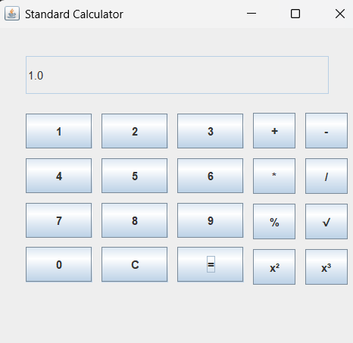

2.mplement the following problem statement using Intellij IDEA.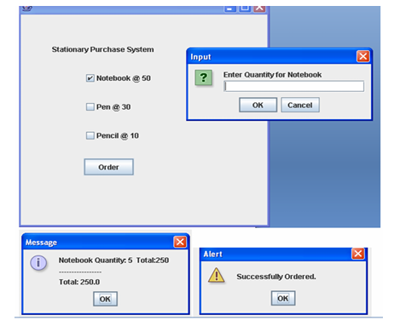

import javax.swing.*;

import java.awt.event.*;

import java.awt.*;

public class CheckBoxExample extends JFrame implements ActionListener {

JLabel l;

JCheckBox cb1, cb2, cb3;

JButton b;

CheckBoxExample() {

l = new JLabel("Stationary Purchase System");

l.setBounds(50, 50, 300, 20);

cb1 = new JCheckBox("Notebook @ 50");

cb1.setBounds(100, 100, 150, 20);

cb2 = new JCheckBox("Pen @ 30");

cb2.setBounds(100, 150, 150, 20);

cb3 = new JCheckBox("Pencil @ 10");

cb3.setBounds(100, 200, 150, 20);

b = new JButton("Order");

b.setBounds(100, 250, 80, 30);

b.addActionListener(this);

add(l);

add(cb1);

add(cb2);

add(cb3);

add(b);

setSize(400, 400);

setLayout(null);

setVisible(true);

setDefaultCloseOperation(EXIT_ON_CLOSE);

}

public void actionPerformed(ActionEvent e) {

float amount = 0;

String msg = "";

if (cb1.isSelected()) {

int q = Integer.parseInt(JOptionPane.showInputDialog(this, "Enter Quantity for Notebook"));

amount = amount + 50 * q;

msg = msg + "Notebook Quantity: " + q + " Total: " + (50 * q) + "\n";

}

if (cb2.isSelected()) {

int q = Integer.parseInt(JOptionPane.showInputDialog(this, "Enter Quantity for Pen"));

amount = amount + 30 * q;

msg = msg + "Pen Quantity: " + q + " Total: " + (30 * q) + "\n";

}

if (cb3.isSelected()) {

int q = Integer.parseInt(JOptionPane.showInputDialog(this, "Enter Quantity for Pencil"));

amount = amount + 10 * q;

msg = msg + "Pencil Quantity: " + q + " Total: " + (10 * q) + "\n";

}

msg += "-----------------\n";

JOptionPane.showMessageDialog(this, msg + "Total: " + amount);

JOptionPane.showMessageDialog(this, "Successfully Ordered.", "Alert", JOptionPane.WARNING_MESSAGE);

}

public static void main(String[] args) {

new CheckBoxExample();

}

}

**Output**

